COIN CHANGE PROBLEM – RECURSIVE IMPLEMENTATION

* There are 6 different kinds of Australian Coins.
* In cents, their values are: 5,10,20,50,100,200
* The problem here is in how many different ways can we produce a handful of COINS adding up to $4?
* KEY TO SOLVING IS TO FIND A WAY TO BREAK IT DOWN INTO SIMPLER SUB-PROBLEMS.

Coin Change Problem: Decomposition

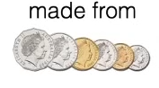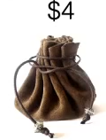

* The $4 can be made from any of the coins, 100($1), 200($2), 50 or 5 cents (COMBINATION OF THESE).
* The Bag $4 could contain one of these each of these coins.
* So the highest denomination among the above coins would be 200 cents or $2.
* So initially, we would check if the bag would contain at least one $2 COIN?
* 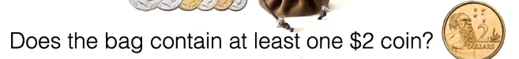
* If so,
* Or if not,
* 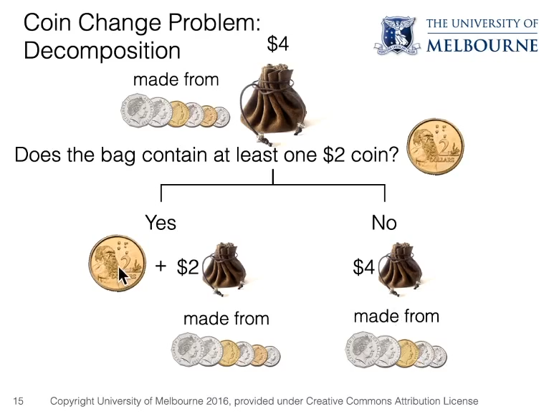
* So here there are two different possibilities, The Bag would contain $2 and another $2 or $2 made from other denominations (50 cents, 1 Dollar or any other values.)  (The $2 GOLD COIN).
* Or the Bag does not contain $2 and has $4 which is made from all other coins other than $2. Here we have reduced the problem either by reducing the amount that we would have or by reducing the
* SO THE NUMBER OF WAYS MAKING $4 IS THEREFORE :
* 